

Voice
Voice

This is the first and oldest instrument

The ability to sing is the simplest instrument to use and the hardest instrument to master.

According to the Golden Encyclopaedia of Music

There are three ranges in men’s voice And three ranges in women’s voices
Tenor . Soprano

Baritone . Mezzo- . . Soprano
Bass . Alto

Occasionally people can sing beyond these normal ranges due to natural ability or practice, and some people cannot reach all the notes in a range. Also male falsetto voice may give an octave above the top limit of a range.
In the SCA voice is the most common of all instruments.

In period vocal music was written in many styles

Chant - The origins of chant go back to antiquity. Hebrew and Greek music likely lead to the use of chant in the Christian church. Gregorian chant is the most commonly known but not the only form of chant practiced in period. Originally each group of Christians in the early church developed it’s own form of chant.

Opera - The beginnings of modern opera are seen in period, Dafne, written by Jacopo Peri and performed as private entertainment for Count Corsi in 1597 (Florentine), and the first one, Euridice, publicly performed in 1600. Euridice was written by Peri and Guilio Caccini and performed for the wedding of Henri IV of France and Marie de’Medici in Florence.

Secular - Every culture developed it’s own vocal music and it was used for every occasion. Every class of people sang; parody, love, criticism, teaching, grief, and every other conceivable emotion or occasion was expressed in song.

Woodwinds
Woodwinds

Primitive Flutes can be dated back 20,000 years ago to Palaeolithic man, and came just slightly before the invention of the trumpet. These earliest woodwinds were made from bone, reed, feathers, wood, shells, bamboo, or clay.

Pan Pipes - These pipes are depicted on Greek and Roman pottery, and were still in use in Europe during the Middle Ages. They were mentioned as court instruments during Charlemagne’s time reaching their height in the 10th and 11th centuries. By the 13th century they had almost completely faded from use in professional and courtly music, and the recorders and flutes started their rise in popularity.

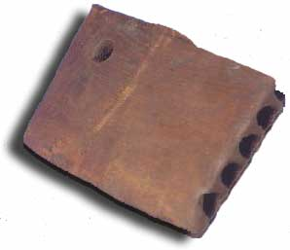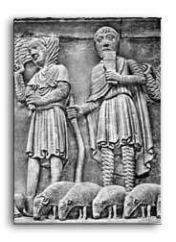
Pan Pipes from a 10th century pit at Coppergate in York. Ancient Roman depiction of Pan Pipes.

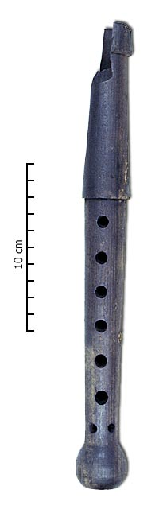
Recorders - From the middle of the 12th century until the middle of the 18th century the recorder was commonly employed in courtly and professional music. They were considered the most useful member of orchestra’s in the fifteen and sixteen hundreds. Recorders are usually one of the first instruments we are introduced to in school. They are easy to start learning on but very hard to master. They come in four ranges (and sizes): soprano, alto (the most common), tenor, and bass. There is also a sopranino – which is higher and smaller then the soprano recorder.
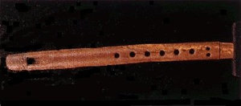
12th century Dordrecht, recovered from a French moat

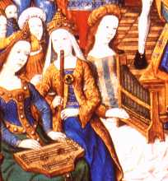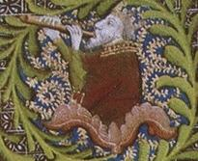
René II Copying the Psalms Jesse Tree (1411), from a Bible, 14th century 'Göttingen Recorder'
(ca 1442-1453), from the Breviary in French
of King René II of Lorraine

Tin Whistles - 12th century bone whistles have been excavated in the Norman quarter of Dublin, but there are indications that whistles similar to what we call tin whistles existed in the 3rd century. These early Irish whistles were called feadan or cuisle and were made from bone, reed, elder, wood, cane, or other grasses. In Scotland the Tusculum whistle, made of bronze or brass, strongly resembles the tin whistle of today, was found with pottery dated from the 14th and 15th centuries. Although the tin whistle has become quite popular in modern Celtic music, it was not considered a serious instrument, and remained as a folk instrument in period.
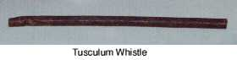
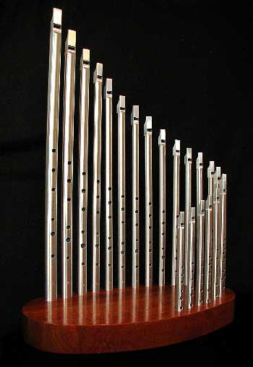
Modern Overton Whistle set

Flute - 9th century B.C. or earlier a form of transverse flute was used in China. The earliest pictures of flutes in Western society comes from 10th century pictures in Byzantium and are common in 10th and 11th century manuscript pictures. In the 11th and 12th centuries the flute made it’s way across Europe and was called the flûte d'Allemagne or the 'German flute'. They rise in popularity until the early 1400’s when they suddenly are mentioned rarely, but by the latter half of the 15th century they move into military use and their popularity rises again. In the 1500’s the flute was used both in the military and in courtly music. Like recorders flutes of this time period came in various sizes and ranges, and were used in consort playing, like recorders. What later became the common concert flute, a Boehm flute, was developed in 1832.
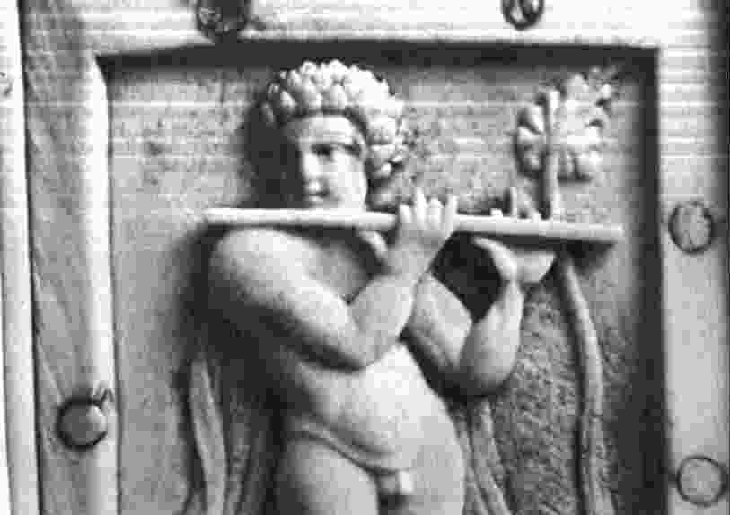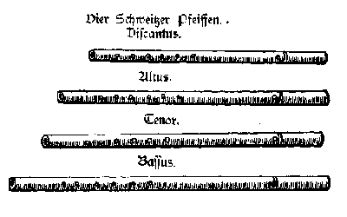
Byzantine flutist from an ivory box (10. century) Illustration from Musica instrumentalis deudsch
by Martin Agricola, Wittenberg, 1528

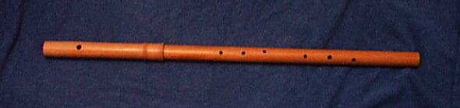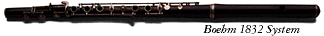
Typical renaissance flute Boehm flute (1832)

Fife - The fife is a descendant of the transverse flute, its first appearance was as a Schwitzerpfeiffen (Swiss fife) in the 10th or 11th century. In the early 1500’s the Swiss fife was used to control military movements in battle. 1534 the fife was in regulation use in France (two fifes, and two drums per company of 1000 men). During this time the fifes were also brought to England as part of the King’s band. By 1539 British citizens were using them at Christmas festivals, and 1550’s on the stage and in the British military.
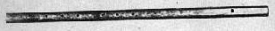
Keyless cylindrical flute from 1550
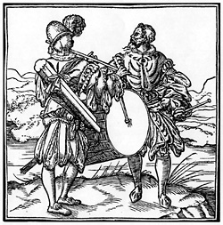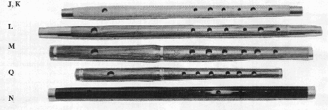
A woodcut from Leonhard Fronsperger's Modern Sweetheart replica military fifes
manual of military discipline. (Frankfurt, 1555),

Percussion


Percussion instruments are the second oldest instrument in the world after the voice. They make up the largest and constantly growing family of instruments. Anything you can hit something to cause an audible sound is a percussion instrument. They also make up the instruments used in the oldest form of orchestra, the Gamelan, from China; which consists primarily of gongs, bells, and drums.

Singing Bowl - Surviving examples of this Tibetan instrument have been dated back to the 10th century but oral tradition places them at 560 B.C. They are commonly found in temples, monasteries, and meditation halls. They are played in one of two ways - either by striking the bowl to produce a bell like sound or running the striker along the edge of the bowl to produce a harmonic, much like the way you would play a wine glass.

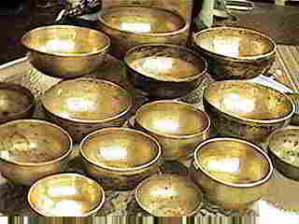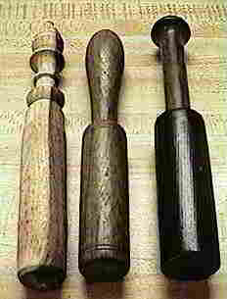
Singing bowls Singing bowl strikers

Castanets - Most commonly identified with Spanish music, castanets have been used by dancers since the days of ancient Rome or Phoenicians who settled in Spain in the 11th century B.C. Spanish dancers were judged by their playing of the castanets as well as their dancing. Usually, a set on each hand is used - the left hand playing the simple beats and the right playing complex dance rhythms.

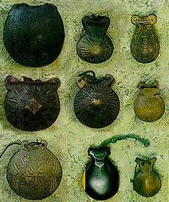
Iberian crusmata (castanets)

Rattle - An instrument that reaches back to the times of primitive man, and made from anything that can be shaken to make a sound. Bunches of stones, nuts, bones, beads, teeth, seeds, or anything small and hard were enclosed in containers or tied to ankles or wrists to make rattles. In the SCA we commonly hear them amongst the Middle Eastern dancers.
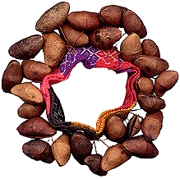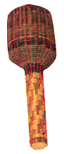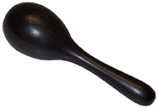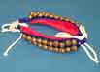
A modern African seed rattle A Cameroon basket rattle Wooden Maraca Ankle or Wirst Bells

Drum - Among the most ancient instruments, the drum is virtually anything (hide, parchment, or skin) that is stretched over a hollow body (wood, metal, or clay). The timpani was first brought to Europe from Turkey in the 1500’s and only high noblemen were allowed to own one, and for many years after they were considered aristocratic instruments used for fanfares along with trumpets. The most common drum seen in the SCA is the Bodhrán, an Irish drum. Oddly, the Bodhrán’s history has been lost to time and it stood outside the realm of common instruments until the 1960’s when the beginnings of the Celtic music craze started. In period it was likely only used in warfare, or by mummers in Ireland.
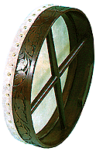
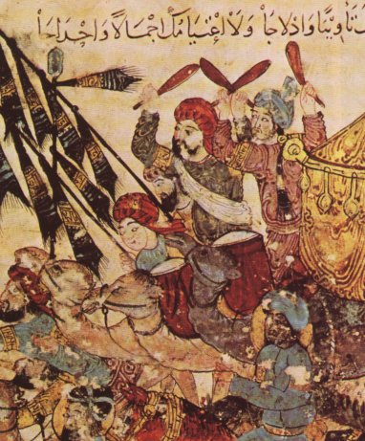
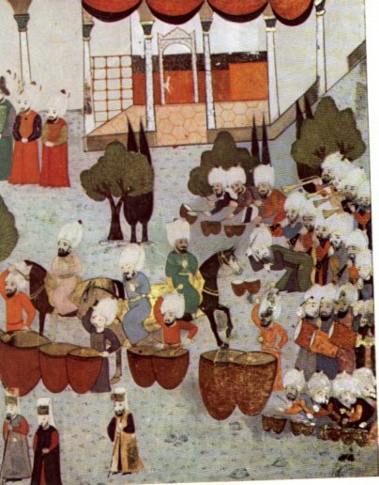
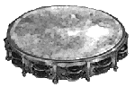

A Goblet shaped Drum. Kettle Drums.
"Cantigas de Santa Maria” Maqaamaat by Hariirii, painted in Timpani Drums.
Frame Drum or Bodhran (Alfonso X "E Sabio" (1221-1284)). Baghdad in 1237 1592, Turkish Military Band.

Strings

Stringed instruments also come from the days of primitive man, with the earliest one possibly being the sound of an arrow being released from a bow. 2000 B.C. forms of the lyre and harp were used in ancient countries, and are frequently depicted on Greek pottery. Bowed strings seem to have originated in the near east.

Fiddle - Also called the vielle, in the 12th and 13th centuries the fiddle was frequently played by minstrels and jongleurs, and was considered one of the most popular medieval instruments. One string was used as a drone and was plucked by the thumb. The other strings were bowed.
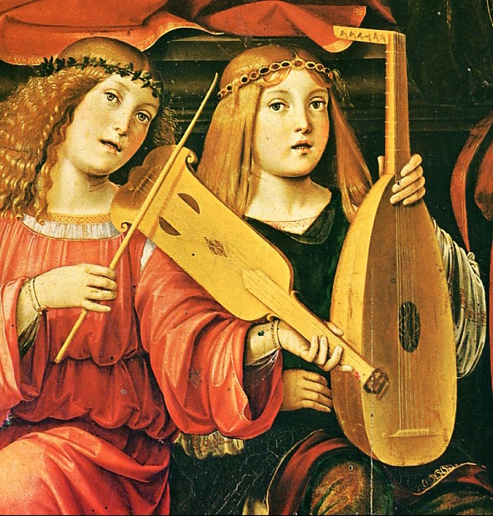
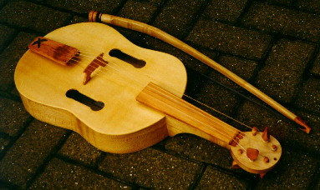

Reproduction Medieval Fiddle based on a late 13th century
carving from Lincoln Cathedral.

A viela or vihuela and a Lute.
Francesco Rabolini detto il Francia (1450ca-1517), Angeli
musicanti (Madonna della Cappella Bentivoglio), Chiesa
di S.Giacomo Maggiore, Bologna.

Violin - A descendant of the fiddle or vielle (a Near Eastern instrument - favoured by minstrels and troubadours of the middle ages) and the rebec (and Arabian instrument). During the 1500’s Viols developed - one form was held between the legs or on the knee, called a viole da gamba (leg viols); the other was held in the arms viole da braccio (arm viols). The violin is a modern version of a soprano or treble arm viol. The violin’s earliest job was to play for dancers or in theatres, and was used as early as 1581 in the orchestra that played for the first ballet. The earliest violin makers were Italian, and many were originally trained as lute makers. Antonio Stradivarius (c1644-1737), the famous violin maker, studied under the grandson of the man who created the first modern violin.
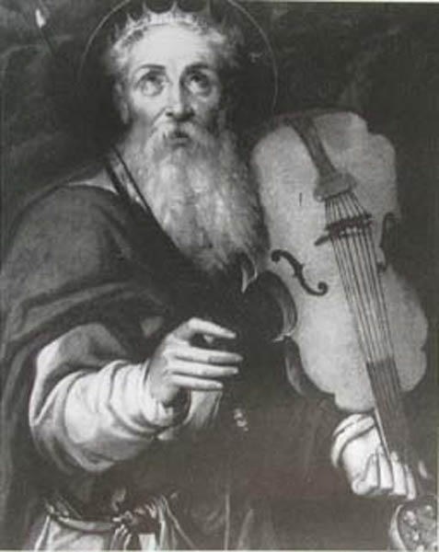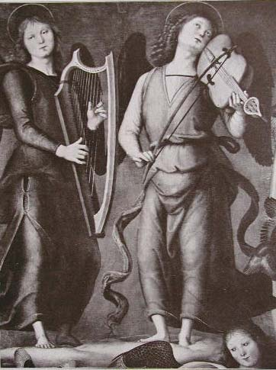
David, Bartolomeo Passerotti, Fragment of Peitro Perugino, Extasy of St.Francisk, Giovanni Francesco
1529-1592, Italy 1446-1524, Italy Barbieri detto il Guercino, 1620, Italy

Lute - It is speculated that the lute originated in the Fertile Crescent or the Caucasus. It traveled into Europe at the end of the 13th century through the returning crusaders and the Moors in Spain. By the 1400’s the strings had doubled and it was plucked and strummed with fingers instead of a plectrum (a quill or birds claw); and it had become the lute we commonly think of. It quickly became a favoured instrument over the course of the Renaissance and was used throughout Europe.
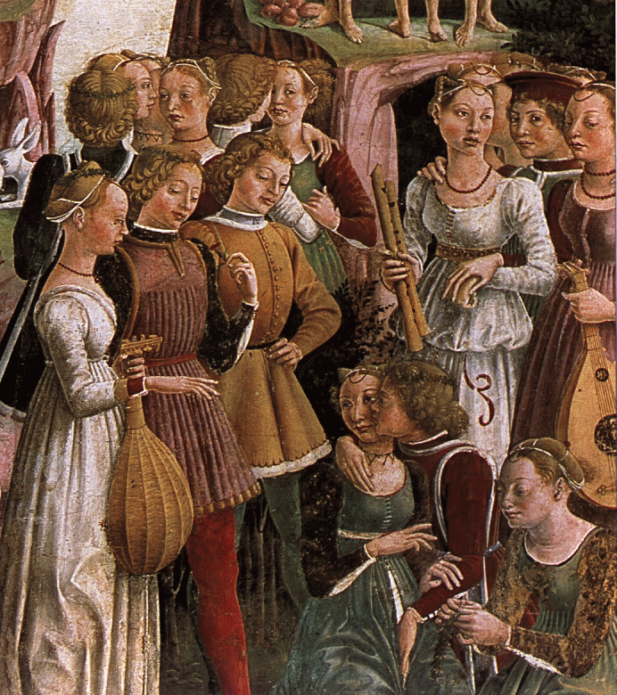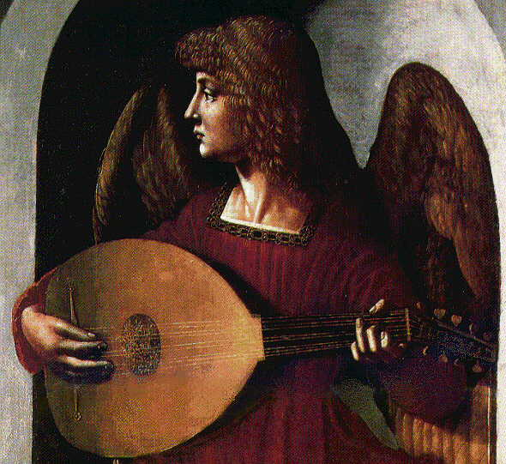
Lutes and Recorders shown. Attributed to an associate of Leonado da Vinci (c1500)
The Triumph of Venus, by Francesco National Gallery. London.
Cossa, 1470.

Guitar - The guitar was first played 5,000 years ago in Egypt. The Romans brought it to Spain, and by 1500 it had become the Spanish national instrument - called a vihuela. Louis Milan (1500-61) wrote a book of music and instructions for playing the guitar. From there many composers wrote music for the guitar and included it as part of their chamber ensembles. In 1526 the guitar made its was to Mexico along with the Spanish settlers.

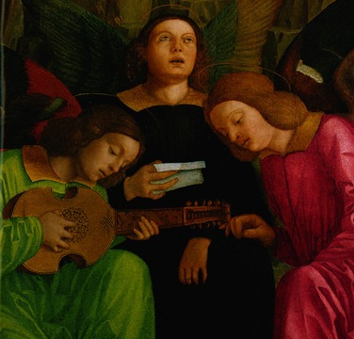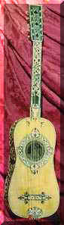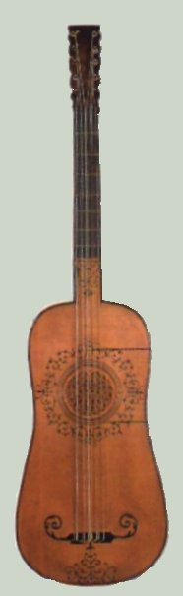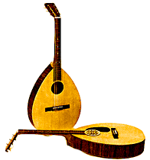
Angels, one playing a guitar. Pre 1500. 16th century vihuela Medieval 4- string Guitar Renaissance guitar

Mandolin - This is the modern survivor of the Renaissance lute. This instrument is popular around Naples (Italy) and is commonly used to play love or folk songs. A painting by Agnelo Gaddi (1369-1396) depicts a mandora (a miniature lute). The miniature lute was probably created fill out the scale of 16th century lute ensembles. It was called a Pandura by the Assyrians, a Dambura by the Arabs, a Mandora by the Latins, and a mandola by the Italians. The smaller version of the traditional Italian mandola was called mandolina. Orville Gibson created the first modern mandolin, which has a flat back, in 1905.
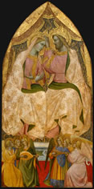
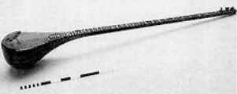
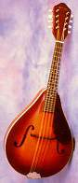

Miniature Lute

Modern Mandolin Agnolo Gaddi, The Coronation
of the Virgin, probably c. 1370

Harp - This instrument is pictured on four to five thousand year old vases from Babylon, making it one of the oldest stringed instruments. There is a existing 2,500 year old Harp displayed in the Egyptian exhibit at the Metropolitan Museum of Art (NYC). It is the national instrument of Wales and Irelands, and was common thought Europe during the Middle Ages and Renaissance. The predecessors of sharping keys (originally introduced as pedals) were introduced in 1810. The modern concert harp has 47 strings and seven pedals.
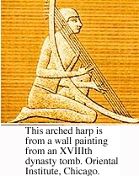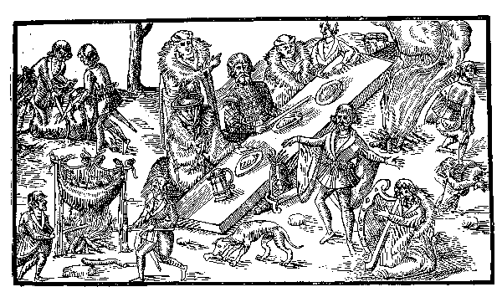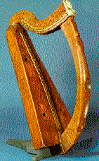
Reciter and harper performing before a chief. John Harp at Trinity College, Dublin.
Derricke, Image of Ireland, 1581. 15th or 16th century

Other
Other

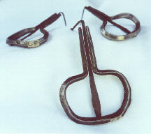
Jaw Harp - Also called the Jew’s harp, Juice harp or Mouth harp. It is not part of Jewish history or music, but has been connected in English with them for the last 400 years, in 1595 it was written about as the jewes trump. It’s origins and age is uncertain, the oldest one found in Japan and dated to 900. It was a well-known folk instrument by the Middle Ages in Europe, and many have turned up in excavations from Anglo Saxon and Carolingian times. Since 1511 there has been an on-going debate as to if this is a percussion instrument or a chromatic instrument. Versions of the jaw harp are made from bamboo in Southeast Asia.

Brass
Brass
The ancestors of Brass Instruments were animal horns and conch shells. The first brass instruments were used in orchestras were the trumpet and the French horn (the medieval hunting horn).
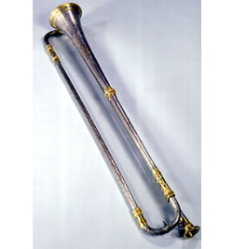
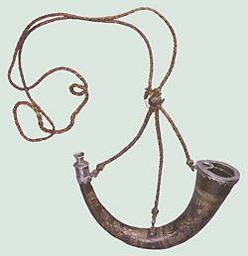
Trumpet, Anton Schnitze Hunting Horn, Italian,
Nuremberg, 1581 16th Century

